

*ISM 254*

*Project submission part 1*

|  |
| --- |
| ***Student number*** |
| **24694274** |
| **Name** |
| **Byron Kraus** |

(UNECE, 2013)

# Site Diagram

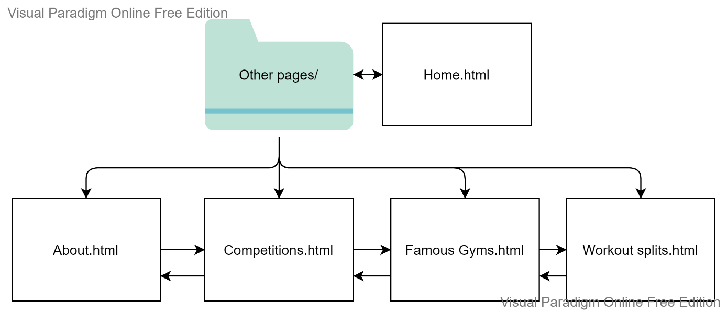

1. **Content Strategy**

**Content Design:**

* **Editorial strategy**

The editorial mission of my webpage is to expose more people to the workout lifestyle in hopes of inspiring people to start working out and looking after their bodies. I aim to influence anyone who is naïve to the gym and exercising and would like to become more involved for health benefits or personal goals.

* **Experience Design**

The user just needs a laptop and an internet to be able to connect to the website and view it, the content is very user-friendly and is created in English for English readers. The customer will start at the home page, being able to read up on a brief definition of weightlifting, they can then look at the competition page, famous gym page, workout split page or about page and can move freely between the pages from one to the next.

**System Design:**

* **Structure (also known as content engineering)**

The program is made with lots of divisions to allow the user to easily move between the pages and within the pages. The pages are well structured for efficient viewing and the content will be restructured when CSS styling is implemented to create a more efficient page.

* **Process Design**

The content will need to be updated each year and when necessary to ensure the website is up to date and the top 10 and top 5 lists are up to date. We care for the existing content when there is a new updated famous gym, competition result or workout split.

# References

UNECE, 2013. *UNECE promotes innovative entrepreneurship in Southeast Europe.* [Online]   
Available at: https://unece.org/media/Economic-Cooperation-and-Integration/press/1661  
[Accessed 10 August 2022].